MIDI OUTPUT BOARD
MIDIOUT-N

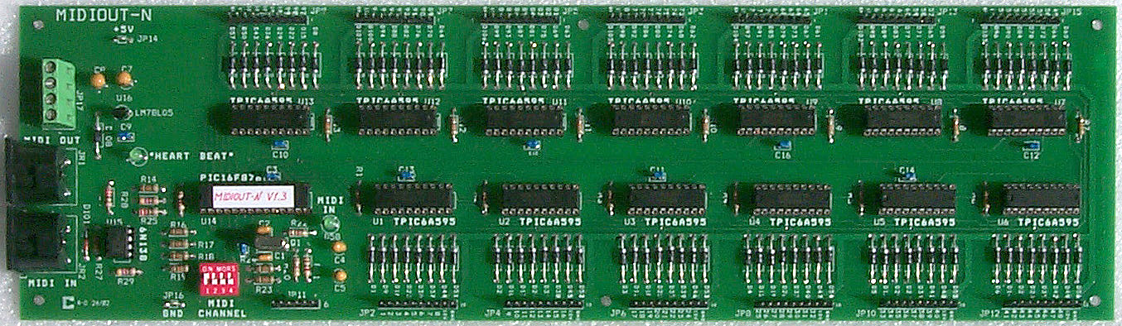

General

The Classic MIDI Output Board may be used as a pipe driver to allow connection of wind-blown pipes to an electronic organ. Outputs are capable of driving relays or pipe-chest magnets requiring up to 0.35A at 35V. This MIDI product allows up to 104 individual outputs to be activated and deactivated through standard MIDI Note-On and Note-Off messages.

Brief Description

The MIDIOUT-N unit consists of a single printed board.
Output connectors may be made with pluggable headers using crimped pins (Molex) or mass-termination insulation-displacement connectors (MAS-CON).
Standard 5-pin DIN connectors are used for MIDI input and output.
MIDIOUT-N boards may be cascaded for more than 104 outputs as each board may have a unique channel number.

Principal Features
- MIDI Channel set by DIP-Switch.
- 104 outputs, which can drive relays, motors, solenoids, LEDs, or incandescent lamps.
- Or 2x 52 outputs controlled by two adjacent MIDI channels (perhaps for two pedal ranks).
- All outputs have over-current protection, and include output transient-protection clamping diodes for use with voltages up to 35V.
- MIDI output connector allows cascading of MIDIOUT-N boards.
- Two LEDs indicate the working status of the board.

Power Supply

Power for MIDIOUT-N can be from any standard DC supply providing between +7 and +35 Volts at a minimum current of 50 mA. The external loads are powered externally but their common +V supply must be returned to the board drivers so that these devices can be adequately protected against reversed-voltage back-e.m.f from inductive loads. An external 0V connection is also required.

MIDI Features

Any output pin can be turned On or OFF by sending a standard MIDI Note-On and Note-Off message. Output “ON” mean that it has current-sinking capability (active-low).

In the Normal mode with 104 contiguous outputs, Output-13 is equivalent to MIDI-key number 36 (24 hex) (Key #1, bottom-C, on an organ keyboard). Note that the output range starts one octave up to allow for transposition and sub-octave coupling (i.e. the MIDI note for Output-1 would be 24 (18 hex)).

In the Split mode, two adjacent MIDI channels control 52 outputs each (53–104 being controlled similarly to 1–52). Output-1(53) is equivalent to MIDI note number 36 (bottom-C on an organ keyboard). Note that both output ranges start at their lowest output numbers.

Key  Note # | Key  Name | MIDI  Note # | Normal  Output # | Split  Output # | Remarks
1 | C1 | 36 (24h) | 13 | 1, 53 | Bottom-C
2 | C#1 | 37 (25h) | 14 | 2, 54
etc. | etc. | etc. | etc. | etc.
25 | C3 | 60 (3Ch) | 37 | 25, 77 | Middle-C
32 | G3 | 67 (43h) | 44 | 32, 84 | Top Pedal
37 | C4 | 72 (48h) | 49 | 37, 89
49 | C5 | 84 (54h) | 61 | 49, 101
52 | D#5 | 87 (57h) | 64 | 52, 104
61 | C6 | 96 (60h) | 73 | – | Top Key
73 | C7 | 108 (6Ch) | 85 | –
85 | C8 | 120 (78h) | 97 | –
92 | G8 | 127 (7Fh) | 104 | –

Unit Configuration

A 4-section DIP-Switch allows the MIDIOUT-N to be set to receive on any one of sixteen channels.
A 6-pin header with links controls board functions: Joining 1&2 lets the chosen MIDI channel control outputs 1–52 while the next higher MIDI channel similarly controls 53–104 (as 1–52). If the Main channel is 16, then the secondary channel will be 1. Joining 2&3 allows control of all 104 by the chosen MIDI channel(s).
Pin-5 is for an external Board Enable control, and is normally linked to pin-4. An external voltage may be used to pin-5 provided that it does not exceed +5V.

SPECIFICATIONS

Dimensions:
Width 14.0 inches, 35.56 cm
Height 4.00 inches, 10.16 cm
Depth 1.00 inch, 2.54 cm

Installation:
Mounting Should be spaced away from any woodwork or other panels. No special ventilation necessary if mounted clear of obstructions.

Controls:
Configuration 4-section DIP-Switch to select input channel (1-16).

Connections:

Inputs:
MIDI DIN 5-pin Socket. Standard MIDI signals, optically isolated.

Power +7 to +35V, 50mA.
4-way Terminal Block

Outputs:
MIDI DIN 5-pin Socket. Standard MIDI signals as per input.

Load Outputs Outputs have continuous current-sinking capability up to 350mA.
13 groups of 10 pins (8 pins – Drive Outputs Pins 1–8, Common Pin-9, Ground pin-10),
0.025" Square, 0.3" long, 0.1" pitch (for 8-pin Molex or MAS-CON connectors)
Load Common Load common +V must be returned to the output drivers’ common for device protection. (Pin-9 of each output connector).

MIDIOUT-N MIDI PARAMETERS

FUNCTION | TRANSMITTED | RECOGNIZED | COMMENTS
Channel 1-16 | Yes (Note 1) | Yes (Note 2) | Key On/Off Data
Mode | Mode 3 | Mode 3 | OMNI OFF, POLY
Note Number | 0-127(Note 1) | 24-127
System Exclusive | Yes | Yes | Note 4
System Common | Yes (Note 1) | Yes (Note 1)
System Real Time Clock  Start  Stop  System Reset | Yes (Note 1) | Yes (Note 1)  No  No  No  Yes (Note 1)
All notes off | Yes (Note 1) | Yes (Note 1)
Notes:
- All MIDI data received on MIDI-In is re-transmitted on MIDI-Out.
- Note data is recognised on whichever channel is active. Default channel is set by DIPSW.
- Program Change messages may be sent on the currently-active channel or on Channel 16.
- SysEx messages received in MIDI-In will be re-transmitted on MIDI-Out.

